# Objective/Overview

The Wolverine Direct Product Management web application will provide a way for users to easily maintain all of their product data that is displayed on WolverineDirect.com. This web-based application will allow users to do the following:

* add and update product and marketing information per brand (Sales Organization/Distribution Channel)
* assign technologies/features to product
* create navigation hierarchies for product
* preview how product will look on the Wolverine Direct site
* ability to publish changes (for next integration run)

# Technical Specifications

The application will be written in ASP .NET 3.5 using MVC 2 and will communicate with a MSSQL database using Fluent nHibernate.

There will also need to be another console application running with Windows Task Scheduler to generate the integration files that are sent to iCongo nightly. This application will use much of the same functionality as the current Marketing Generator tool, but will be automated and go after the database data of this application instead of spreadsheets.

## Data Imports

Data will need to be imported from SAP on a nightly basis. A program has been written (SE38 : Z_ICONGO_MATERIAL_EXTRACT) to export the SAP data to a text file. From that point a SQL BULK query can be executed on that file to import it into a table for use in the web application. That query is as follows:

BULK

INSERT B2BExtract

FROM '<filename>.txt'

WITH(FIELDTERMINATOR = '|', ROWTERMINATOR = '\n')

GO

This nightly process will be a console application coupled with Windows Task Scheduler. The above query will be executed and previous data will be backed up and replaced. Once the table is populated with the latest data, the next time a user logs in they will be notified if there are any additions or updates available for their products. However, nothing in the web application will automatically be updated that the user sees. All changes must be manually done or approved by the user so as not to have any discrepancies between what they’ve done and what is on the site. There will be some sort of notification that updated product information is available for viewing and approval and the user can then choose to update or not.

## Services

To make it easier on users who must maintain product data on numerous products and to reduce redundancy, there will also be a web service available for importing B2C XML product information. This will also run on a nightly basis to make sure to have the latest product data. It will most likely be a part of the SAP data import process application.

# Detailed Overview of Functionality

## Login

Logging in will be done by using a username and password. Users will be able to create a login per brand using a brand password that is stored in the database. In the future, we will need to build better security but this will work for the short term.

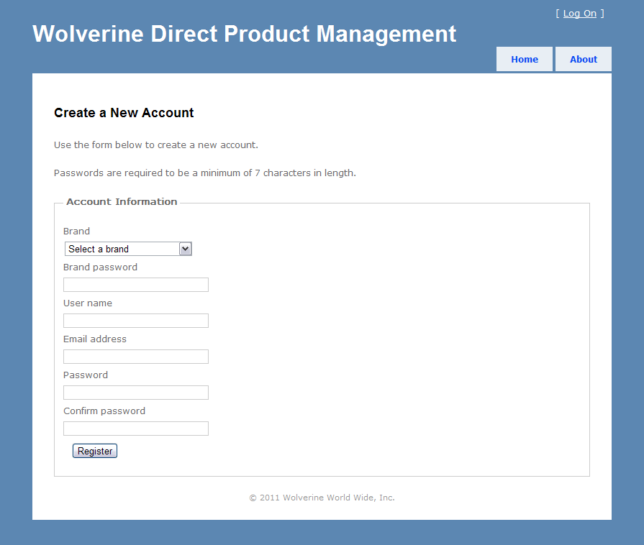

## Technologies/Features

Users will be able to assign technologies/features to specific or groups of products. There will be an area to create technologies/features per brand. There will also be an area that shows the user a list of unassigned product with the ability to assign features/technology to that product. The user will be able to see the different categories of technologies/features with the products that are assigned to them.

Currently, in working with the spreadsheets, flags are handled at the pattern level. However, Wolverine handles flags at the style level. It will be an easy change to implement flags at the style level in this application. Navigation should work the same.

## Style Marketing (Pattern/Color)

This would allow for viewing SAP and B2C marketing information for patterns with corresponding colors with the option to overwrite it. However, certain fields will be read only such as gender and size run. The pattern name that comes from SAP is generally not very ‘pretty’ so the user will have the option to change that, but will still be saved in the database by the SAP pattern name to group styles together. The user will see a list of product possibly in a table view that displays the marketing info with an edit button to be able to quickly change information associated to that product.

There will be an option for overwriting product data with the B2C product data from the web service. The options will be to always overwrite with B2C data or never automatically overwrite with B2C data. If the user chooses the latter, they will see the B2C data and will be able to select which styles and specific information to overwrite.

Since so much effort has gone in to using the spreadsheets to feed data into Wolverine Direct thus far, the initial load of product data into this application’s database will be from those spreadsheets. This will give us a good starting point so we don’t lose the user’s work that they’ve put into product information so far.

## Site Merchandising (Navigation)

This would allow for building the navigational structure and assigning patterns or individual styles. The user will see navigational trees and can assign product to each branch. So user will create the last category for navigation then be able to search for patterns somehow to add to the tree (by pattern name & display gender or by style number). New styles that come in for a pattern should be manually added to the navigational structure. No automatic updating. Assignment should be at style number level, but searching will allow pattern name/gender or style.

Some type of preview functionality should be available. They will see the trees as they appear on Wolverine Direct.

## Publishing Module

This will allow users to publish the current state of the catalog to the B2B site. There will be functionality to validate entries against SAP to make sure all values are valid and report errors to the user to allow them to fix any issues.

There may be a need for versioning in the cases of setting up the new upcoming spring line or the like. Users will be able to set up navigation and product and save changes to be published at a later date. This may cause some discrepancies between current and future product so there will need to be some level of ‘smartness’ involved in this functionality.

## Product Images

There will be a separate application created that runs against the product in the database. Show current images to the user when they are editing products. It will periodically check for updated imagery (most likely weekly) for products and ready those files for uploading to iCongo. This will most likely be a console application coupled with Windows Task Scheduler.

# Exceptions

## Canada

As long as Canadian brands have their own unique Sales Organization and Distribution Channel, there will be no issues in adding them to the system. This should allow for duplicate products in the database since each is organized by SO/DC.

## Hytest

Hytest products also have their own Sales Organization and Distribution Channel. It will function much the same way that Canadian products work.